Project- Part 2
There are two Tasks- description starts on page-8.
Deliverables (Project Part 2: Task1)
- All programs: login2T1.html, login2T1.php, and memberInfo2T1.php [and register.html and register.php]- zip them all
Method-1(IDOR):
- The screenshot like image-4. It should include your full browser with the address bar)- the URL should be clearly visible.
- Text: Payload- URL
Method-2 (SQLi):
- Case -1: Text: Payload- Username to display Selva’s profile. Selva’ #
- Case- 2: Text: Payload- Username to display the first record in the database.
Deliverables (Project Part-2 Task 2):
- All programs: login2T2.php, register2T2.php, memberInfo2T2.php, and logout.php (zip)
- And all relevant screen shots (using the above programs – shows on the address bar).
- Login failure
- Login success
- Register- user name is taken
- Register- success- to login page
- Unsuccessful URL Parameter Manipulation

First read the following to learn session management.
Session Management
Introduction to Session Variables
1. What are Session Variables?
- Session variables are used to store information about a user's session. Unlike regular variables, session variables persist across different pages on the website.
- They are stored on the server, providing a way to maintain state without relying on client-side cookies.
2. Why Use Session Variables?
- Session variables are essential for tasks like user authentication, shopping carts, and personalized user experiences.
- They offer more security compared to cookies as they are stored on the server, reducing the risk

3. Practice: Hands-On Activity
Using Visual Studio Code For PHP Development – 36 Chambers – The Legendary Journeys: Execution to the max! (wordpress.com)

3.1. Creating a Basic Session
Step 1: Start a Session and Set a Variable
- Creating the index.php File:
  - Create a new folder named SessionExample in the XAMPP htdocs directory.
(use VSCode)
  - Inside SessionExample, create a file named index.php.
  - Add the following code to start a session and set a session variable:

<?php
session_start();
$_SESSION['username'] = 'student';
echo 'Session started and variable set. <br>';
echo 'Username: ' . $_SESSION['username'];
?>
  - Explanation:
    - PHP code is written inside <?php and ?>
    - session_start(): This function starts a new session or resumes an existing session. It must be called before any HTML or other output.
    - $_SESSION['username'] = 'student': This line sets a session variable username with the value student.
    - echo: This outputs the text to the browser, confirming that the session variable is set.
- Running the File:
  - Open a web browser and go to http://localhost/SessionExample/index.php to see the output.

3.2. Accessing Session Variables on Another Page
Step 2: Create a Second Page to Access the Session Variable
- Creating the profile.php File:
  - Create a file named profile.php in the same folder.
  - Add the following code to access and display the session variable:
<?php s
session_start();
if(isset($_SESSION['username'])) {
echo 'Welcome, ' . $_SESSION['username']; }
else {
echo 'No session variable set.';
}
?>
  - Explanation:
    - session_start(): This function continues the session that was started on index.php.
    - isset($_SESSION['username']): This checks if the session variable username is set.
    - echo: This outputs a welcome message if the session variable is set, otherwise it outputs a message indicating no session variable is set.

  - Running the File:
  - Open a web browser and go to http://localhost/SessionExample/profile.php to see the output.
To view headers and cookies in your browser, you can use the developer tools built into most modern browsers. Below are the steps for viewing headers and cookies in Google Chrome, Mozilla Firefox, and Microsoft Edge.
When a client makes a request to a server with a session, the HTML request will include the session ID in the cookie header. This session ID is used by the server to identify the corresponding session data. Here is an example of what the HTTP request might look like:
• The client's browser sends the session ID to the server in the Cookie header.
• The server uses the session ID to retrieve the session data.
• The server checks the session data to determine if the user is authenticated and acts accordingly.
You can check how your browser store cookies and make requests to servers.
Google Chrome
- Open Developer Tools:
  - Press F12 or Ctrl+Shift+I (Windows/Linux) or Cmd+Opt+I (Mac) to open the Developer Tools.
- View Headers:
  - Go to the Network tab.
  - Reload the page if necessary.
  - Click on the desired request in the left pane (click All first)
  - In the right pane, go to the Headers tab to see the request and response headers.
- View Cookies:
  - Go to the Application tab (may need to click on >>)
  - In the left sidebar, under Storage, click on Cookies.
  - Select the website from the dropdown to see the cookies set for that domain.

Mozilla Firefox
- Open Developer Tools:
  - Press F12 or Ctrl+Shift+I (Windows/Linux) or Cmd+Opt+I (Mac) to open the Developer Tools.
- View Headers:
  - Go to the Network tab.
  - Reload the page if necessary.
  - Click on the desired request in the left pane.
  - In the right pane, go to the Headers tab to see the request and response headers.
- View Cookies:
  - Go to the Storage tab.
  - In the left sidebar, expand Cookies and select the website to see the cookies set for that domain.
Microsoft Edge
- Open Developer Tools:
  - Press F12 or Ctrl+Shift+I (Windows/Linux) or Cmd+Opt+I (Mac) to open the Developer Tools.
- View Headers:
  - Go to the Network tab.
  - Reload the page if necessary.
  - Click on the desired request in the left pane.
  - In the right pane, go to the Headers tab to see the request and response headers.
- View Cookies:
  - Go to the Application tab.
  - In the left sidebar, under Storage, click on Cookies.
  - Select the website from the dropdown to see the cookies set for that domain.
Safari (macOS)
- Open Developer Tools:
  - Press Cmd+Opt+I to open the Developer Tools.
  - If you do not see the Develop menu, go to Safari > Preferences > Advanced and check the Show Develop menu in menu bar option.
- View Headers:
  - Go to the Network tab.
  - Reload the page if necessary.
  - Click on the desired request in the left pane.
  - In the right pane, go to the Headers tab to see the request and response headers.
- View Cookies:
  - Go to the Storage tab.
  - In the left sidebar, click on Cookies to see the cookies set for the domain.

  - Destroying a Session
Step 3: Create a Logout Page to Destroy the Session
- Creating the logout.php File:
  - Create a file named logout.php in the same folder.
  - Add the following code to destroy the session:

<?php
session_start();
session_unset();
session_destroy();
echo 'Session destroyed.';
?>
  - Explanation:
    - session_unset(): This function frees all session variables.
    - session_destroy(): This function destroys all data registered to a session.
    - echo: This outputs a message confirming that the session has been destroyed.
- Running the File:
  - Open a web browser and go to http://localhost/SessionExample/logout.php to see the output.

3.5. Securing Session Variables
1. Regenerating Session ID
Explanation:
- Regenerating the session ID helps prevent session fixation attacks by creating a new session ID whenever a significant event occurs (e.g., user login).
- Modifying the Login Script:
  - Add the following code to regenerate the session ID upon successful login:
session_regenerate_id(true);

2. Setting Secure Session Cookie Parameters
Explanation:
- Secure session cookies are essential to prevent session hijacking by ensuring cookies are only sent over secure (HTTPS) connections and are inaccessible via JavaScript.
- Setting Secure Parameters:
  - Add the following code before session_start() to enhance session security:
ini_set('session.cookie_lifetime', 0);
ini_set('session.cookie_httponly', 1);
ini_set('session.cookie_secure', 1); // Only use if your site is on HTTPS session_start();

The above instructions are for you to practice. You don’t need to submit anything.

Project- Part2: YOUR TWO TASKs
In project part-1 we haven’t used session variables. This assignment is continuity of part-1.
Here are two tasks. Task1 is related to attacks and Task2 is related to the remedies.
Here we will learn the usage of session management in authentication.
First, we will learn why session management is important.

We created login.php in part-1. This is used to check the users’ credentials and to display their member number if they are authenticated.
In this task we will display the full profile (not only the member number). Your aim is to display the member’s information from the member table in the database, if it is authenticated.
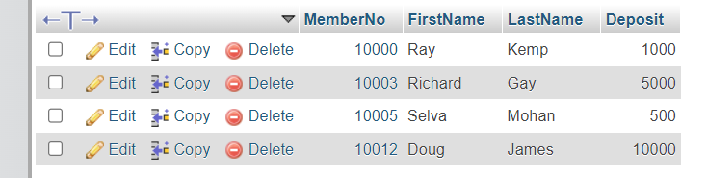
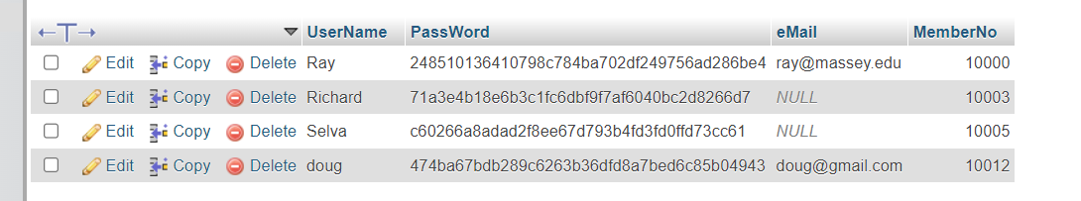
For example, type the url below and give Ray’s username and password.
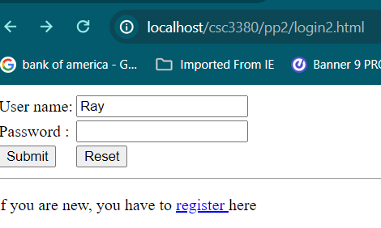
If you give the correct password, you should get the following screen.

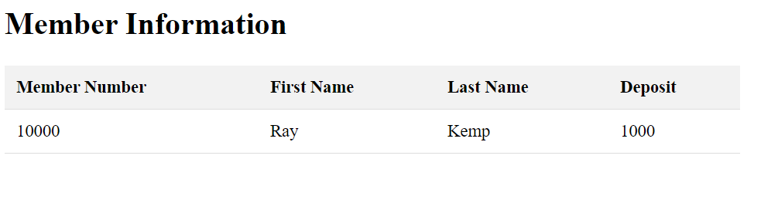
image-1
Recall: in Part-1 you just got the member number- not names
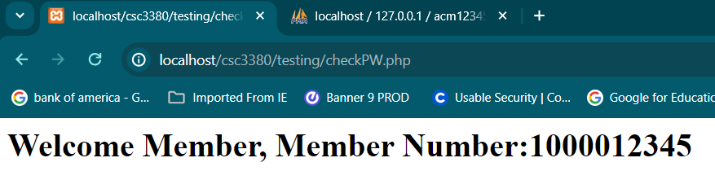

Copy the folder CSC3380PP1 and paste it in htdocs. Rename the folder CSC3380PP2T1,
We need to modify login.php. Rename the login.php in the new folder as login2T1.php. This program will be used to check the users’ credentials and if they are authenticated display their names and balance in their deposit (using another php file, memberInfo2T1.php – given below)
Also rename login.html to login2T1.html, and change action=login.php. to action=login2T1.php.
<form action ="login2T1.php" method="post">

Note: Whenever you make code changes in VSCode, press CTRL+S to save. Also, refresh the web browser after changes.
Now, we will modify login2T1.php code.
The code for new login2T1.php is given below. The main changes are highlighted.
$response =
file_get_contents("http://localhost/csc3380/pp2/memberInfo2T1.php?memberno=".$memberNo1);
echo $response
Instead of displaying member number alone, a php file memberInfo2T1.php is called. The member number is passed through the url (as a GET not POST). We need to write memberInfo2T1.php (the full code is given below).
function getMemberInfo($conID, &$fName, &$lName, &$deposit, $memberno) gets the details of the member from the database table based on the member number.
*function createMemberInfoHTML($fName, $lName, $deposit) just creates the html web page as a string. This string will be passed to the variable $response in the login2T1.php code. The code echo will render this html string/code on the browser.

MemberInfo2T1.php

<?php
// Check if 'memberno' is set in the GET request
if (isset($_GET['memberno'])) {
$memberno = $_GET['memberno'];
}

//OTHER GLOBAL VARIABLES
$conID; $fName; $lName; $deposit;

//Functions
function openDatabase(&$conID){ //to create a handle $conID for the database
$host = "localhost"; $db = "ACM12345"; $usr = "root"; $pw =""; // change ????
$conID = new mysqli($host, $usr, $pw, $db);
if ($conID->connect_error) {
die("Connection failed: " . $conID->connect_error);
}
}

function getMemberInfo($conID, &$fName, &$lName, &$deposit, $memberno){
$SQL = " SELECT * FROM member WHERE MemberNo = $memberno";
$result = $conID->query($SQL);
if (!$result) {
die( "Query Error: " .$SQL. " :" .$conID->connect_error); // insecure output
} else {
$row = $result -> fetch_array();
if (!$row){ // if the row is empty, user name, password pair is wrong
return false;
} else {
$fName= $row['FirstName']; //should match table's column name
$lName= $row['LastName']; //should match table's column name
$deposit= $row['Deposit'];
$result->close();
return true;
}
}
}

function createMemberInfoHTML($fName, $lName, $deposit){
echo "<!DOCTYPE html>
<html>
<head>
<title>Member Information</title>
<style>
table {
width: 50%;
border-collapse: collapse;
margin: 25px 0;
font-size: 18px;
text-align: left;
}
th, td {
padding: 12px;
border-bottom: 1px solid #ddd;
}
th {
background-color: #f2f2f2;
}
</style>
</head>
//continues on next box

<body>
<h1>Member Information</h1>
<table>
<tr>
<th>Member Number</th>
<th>Name</th>
<th>Deposit</th>
</tr>
<tr>
<td>" . $fName . "</td>
<td>" . $lName . "</td>
<td>" . $deposit . "</td>
</tr>
</table>
</body>
</html>";
}
<body>
<h1>Member Information</h1>
<table>
<tr>
<th>Member Number</th>
<th>Name</th>
<th>Deposit</th>
</tr>
<tr>
<td>" . $fName . "</td>
<td>" . $lName . "</td>
<td>" . $deposit . "</td>
</tr>
</table>
</body>
</html>";
}

// MAIN
openDatabase($conID);
if (getMemberInfo($conID,$fName, $lName, $deposit, $memberno)) {
// Call the PHP page
createMemberInfoHTML($fName, $lName, $deposit);
} else {
echo "<h1> Your information not available- Contact the secretary <h1>";
}
$conID->close();

?>
Image-2

The web is inherently stateless, meaning that each request from a client to a server is treated as an independent transaction that is unrelated to any previous request. Session variables can be used to maintain state across multiple requests. However, the provided programs do not use session variables to record whether a user is already authenticated. This omission can be exploited to attack the website.
For instance, consider a scenario where the deposit information is sensitive for a member and should not be disclosed to others. Without proper session management, it might be possible to access Selva’s records without knowing his password. To understand how this might be done, let’s explore how data is typically retrieved from a database.
Steps to Exploit the Vulnerability:
- Analyze the Web Application: Identify the pages and parameters involved in accessing sensitive information. This usually involves examining the URL patterns and any form submissions.
- Session Hijacking: If the web application uses session identifiers in the URL or cookies, an attacker might attempt to hijack an existing session by capturing the session ID. (we are not there yet)
- Parameter Tampering: If the application relies on URL parameters to fetch user-specific data without proper validation, an attacker might change these parameters to access other users' data.
- Direct Database Access: If the application does not properly authenticate users for each request, an attacker might directly interact with the database queries to retrieve sensitive information.
Example of Exploitation:
- Identify the Vulnerable URL: Suppose the URL for viewing deposit information is http://example.com/deposit?user_id=123.

- Parameter Manipulation: An attacker might change the user_id parameter to Selva’s user ID, e.g., http://example.com/deposit?user_id=456, to view Selva’s deposit information.

Insecure Direct Object Reference (IDOR) vulnerability: where an application exposes internal objects (like user IDs, filenames, etc.) directly in a way that attackers can manipulate. It is often exploited via URL manipulation, but it can also happen in form data, headers, etc.
For example, check the address bar when you open your CSC 3380 page on Canvas. In my address bar, I see https://canvas.uncp.edu/courses/35026.
I should not be able to open my CSC 3380 Canvas page in any other browser just by typing the above URL without first logging in — if I can, then Canvas has an IDOR vulnerability.
Preventive Measures:
- Use Session Variables: Implement session management to ensure that each request is authenticated. Store the user’s authentication status and other relevant information in session variables.
- Validate User Authentication: For each sensitive operation, check if the user is authenticated and authorized to access the requested data.
- Parameter Validation: Validate all input parameters to ensure they are within the expected range and format. Implement proper access controls.
- Secure Session Management: Use secure cookies and regenerate session IDs upon login to prevent session hijacking.

Project Part2: Task1:
If you know Selva’s password, and if you login using that password,
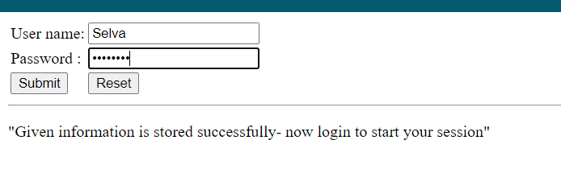
image-3
you will get Selva’s profile page given below.
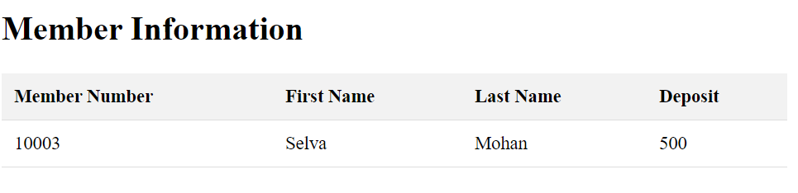
image-4

Obviously, you don’t know Selva’s password. But, your task is to do some research and find a way to display Selva’s profile. In general, you will not be able to access the database or any code segments. Even if you can access the DB the password is normally not available in plain text.

There are at least two ways we can achieve this. In method-1 you will not use login page, but in method-2 (SQL Injection) you will attack the login page.

Method-1: URL parameter manipulation (to exploit Insecure Direct Object Reference (IDOR) vulnerability)
Insecure Direct Object Reference (IDOR) is a specific type of vulnerability where an application exposes internal objects directly in a way that attackers can manipulate. It is often exploited via URL manipulation.
Check the examples of exploitation on the previous page, Identify the vulnerable URL and manipulate the parameter(s), For this assignment, assume that you can figure out Selva’s member number (in my table Selva’s member number is 10005).
Hint: use the information in following code to costruct your payload.
MemberInfo2T1.php

<?php
// Check if 'memberno' is set in the GET request
if (isset($_GET['memberno'])) {
$memberno = $_GET['memberno'];
}

Your payload is the appropriate URL that can be used to display Selva’s profile without knowing his password.

Method-2: SQL Injection
IMPORTANT: If you use prepared/bindparam statements in your PHP code, SQL injection (SQLi) attack will not work. For this section, you are required to work with unsecured PHP code provided before.
For example, the login2T1.html file should include code similar to:
$SQL = " SELECT * FROM memberPW WHERE UserName = '$userName' AND PassWord = sha1('$pw')";
$result = $conID->query($SQL);
SQLi will not work, if you have the code similar to the following:
$SQL = "SELECT MemberNo FROM memberspw WHERE UserName = ? AND PassWord = sha1(?)";
$stmt = $conID->prepare($SQL);
$stmt->bind_param("ss", $uName1, $pw1);
Review:
https://www.w3schools.com/sql/sql_injection.asp
https://en.wikipedia.org/wiki/SQL_injection
https://blog.detectify.com/2016/04/06/owasp-top-10-injection/
A malicious person may login to the system without knowing any login credentials.
Now, as a pen tester pretend that you are a malicious person who is attempting to login to the system as a user whose password is not known to you. In this task, you are required to create a payload (appropriate username and password) to hack this system. You have to use SQL injection to attack the system. If you succeed, case-1, you should get a profile page of any user if the username is known. case-2: You can also get the profile page of the first record even if the username is not known.
In both cases, you must create appropriate username as payloads. The password can be anything.
Case-1: To get a profile page of any user if the username is known.
Your task: Open login page. Give appropriate username (and any password) to display Selva’s profile page.
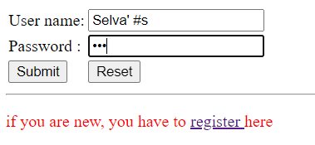
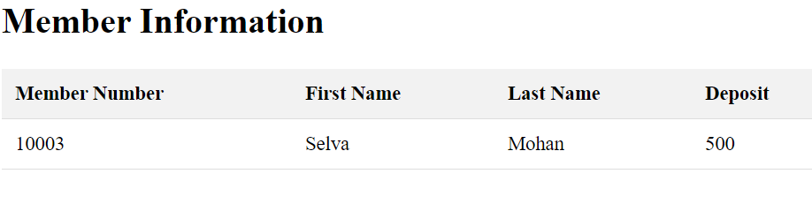
Case-2: To get the profile page of the first record even if the username is not known.
In the given database, we can display the profile of the first record even without giving the actual username (but you have to type appropriate payload for user name)
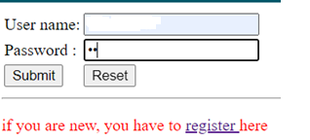
IMPORTANT: Don’t give Ray as username- assume you don’t have any knowledge about the database.
You should get the following image if Ray’s information is the first record in the member table.
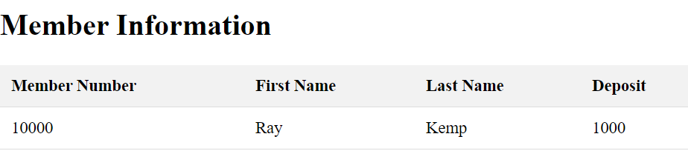

Deliverables (Project Part 2: Task1)
- All programs: login2T1.html, login2T1.php, and memberInfo2T1.php [and register.html and register.php]- zip them all
Method-1(IDOR):
- The screenshot like image-4. It should include your full browser with the address bar)- the URL should be clearly visible.
- Text: Payload- URL
Method-2 (SQLi):
- Case -1: Text: Payload- Username to display Selva’s profile. Selva’ #
- Case- 2: Text: Payload- Username to display the first record in the database. ‘
or 1 = 1#

Project Part 2: Task2
We are going to Implement a multi-page PHP application that uses session variables to maintain user state and includes secure session management practices.
In this task we will combine html and php files.
---
In php file we can include html code also. This feature is convenient but may confuse also.
For example, copy this code and store it on your server as test.php
<p style="color: red;">
<?php
$age = 20;
if ($age < 25) echo "welcome";
?>
</p>
On your browser, if you type localhost/test.php, you will see ‘welcome’ on the screen.
Note that, the file should be stored on the server and its extension should be php (this tells the server that some php code need to be executed on the server site before sending the html part to client site) and open on a client browser using the url.
Check the source code- you should not be able to see the php code.
----
In this task, you will create a simple login system using session variables. The partial codes will be given- you just need to fill in the blanks.
- Register2T2.php need not use session variable. For this we will combine register.html and register.php
- A login page (login2T2.php) that sets session variables. For this we will combine login.html and login2T1.php files.
- A secure page (memberInfo2T2.php) that uses POST requests and checks if a session variable is set.
- A logout page (logout2T2.php) that destroys the session.

First, Create a folder CSC3380PP2T2

Step-1: register2T2.php (combine previous register.html and register.php files)
Using sessions during the registration process in PHP is not strictly necessary, but it can be beneficial for certain scenarios. For instance, if you want to retain data across multiple pages or steps in the registration process, handle temporary storage of user input, or improve the user experience by preserving entered data in case of errors.
Here’s an example of how you might use sessions during the registration process:
Temporary Storage: Store user input temporarily in case they need to go back and edit their information.
Multiple Steps: Handle multi-step registration processes where data is collected across multiple forms/pages.

Create a file register2T2.php and copy and paste the code below.
This file contains combined (partial) code from our previous register.html and register.php files. Fill in the blanks,
Session variables are not necessary here and not used.
<?php
$error='';
if ($_SERVER["REQUEST_METHOD"] == "POST") {
// Get form data
$fname = $_POST['fname'];
$lname = $_POST['lname'];
$email = $_POST['email'];
$deposit = $_POST['deposit'];
$username = $_POST['username'];
$password = $_POST['password'];

//opendatabase function is not used

// Database connection
$conID = new mysqli("localhost", "root", "", "ACM12345");

if ($conID->connect_error) {
die("Connection failed: " . $conID->connect_error);
}

// Check if username is taken
if (usernameTaken($conID, $username)) {
$error='Username is already taken. Choose a different username';
} else {
// Write to database
if (write($conID, $fname, $lname, $email, $username, $password, $deposit)) {
header('Location: login22.php?msg=Given information is stored successfully - now login to start your session');
exit;
}
}

$conID->close();
}
//functions
function usernameTaken($conID, $uName) {
$sql = "SELECT * FROM memberPW1 WHERE UserName = '$uName'";
$result = $conID->query($sql);
return $result->num_rows > 0;
}

function write($conID, $fName, $lName, $eMail, $uName, $pw, $deposit) {
$hashed_password = sha1($pw); // password_hash($password, PASSWORD_DEFAULT);
$sql = "INSERT INTO memberPW1 (UserName, PassWord, eMail) VALUES ('$uName', '$hashed_password', '$eMail')";
if ($conID->query($sql) === TRUE) {
$lastMemberNo = $conID->insert_id;
} else {
echo "Error: " . $sql . "<br>" . $conID->error;
return false;
}

$sql = "INSERT INTO member1 (MemberNo, FirstName, LastName, Deposit) VALUES ('$lastMemberNo', '$fName', '$lName', '$deposit')";
if ($conID->query($sql) === TRUE) {
echo "New member record created successfully.";
} else {
echo "Error: " . $sql . "<br>" . $conID->error;
return false;
}
return true;
}
?>
<!DOCTYPE html>
<html lang="en">
<head>
<meta charset="UTF-8">
<meta name="keywords" content="ACM">
<meta name="viewport" content="width=device-width, initial-scale=1">
<title>ACM Registration Page</title>
<style>
table, tr, td {
border: 2px solid black;
}
</style>
<script>
function validate() {
var letters = /^[A-Za-z]+$/;
var firstname = document.getElementById("fname").value;
if (!firstname.match(letters)) {
alert("Not a valid First Name");
return false;
}

COMPLETE THE REST
}
</script>
</head>
<body>
<h1>Registration Form</h1>
<p style="color: red;"> <?php if ($error) echo $error; ?></p>
<form name="myForm" onsubmit="return validate()" method="post">
<table>
<tr>
<td><label for="fname">First Name:</label></td>
<td><input type="text" id="fname" name="fname" value="<?php if (isset($_POST['fname'])) echo $_POST['fname']; ?>" required></td>
</tr>
<tr>
<td><label for="lname">Last Name:</label></td>
<td><input type="text" id="lname" name="lname" value="<?php echo isset($_POST['lname']) ? htmlspecialchars($_POST['lname']) : ''; ?>" required></td>
</tr>
<tr>
<td><label for="email">Email:</label></td>
<td><input type="email" id="email" name="email" value="<?php echo isset($_POST['email']) ? htmlspecialchars($_POST['email']) : ''; ?>" required></td>
</tr>

COMPLETE THE REST

<tr>
<td colspan="2" style="text-align: center;">
<input type="reset" value="Reset"> <input type="submit" value="Submit">
</td>
</tr>
</table>
</form>
</body>
</html>

Step-by-Step Explanation:
- Initial Page Load (Form Display):
  - When the page register2T2.php is requested from a client browser, the server executes the PHP script.
  - Since the $_SERVER["REQUEST_METHOD"] is not POST (it's GET during the initial request), the PHP block inside the if statement is skipped.
  - The server sends the HTML content (the form) back to the browser. This displays the form for the user to fill out.
- User Submits the Form:
  - When the user fills out the form and clicks the "Submit" button:
    - The form's method="post" causes the browser to send a POST request to the same PHP script.
    - All form data (input values for fname, lname, email, etc.) is sent in the $_POST array.
- Server Processes the Form Submission:
  - On receiving the POST request, the PHP script is executed again.
  - This time, $_SERVER["REQUEST_METHOD"] is POST, so the code inside the if block runs.
  - The server performs the rest of the tasks

STEP-2: login2T2.php
Create a file login2T2.php in your new folder CSC3800pp2t2 and copy and paste the code below.
This file contains combined (partial) code from our previous login2T1.html and login2T1.php files. Fill in the blanks.
Most importantly, this code includes session variables also.
Explanation:
- session_start(): Resumes the session.
- if password is correct.
  - regenerates the session
  - set the session variables username and memberno
    - this username session variable will be used in subsequent requests
  - direct to the profile display page (memberInfo2T2.php)
- If not, set the error message, and stay in login2T2.php.
- There is no action= “login2T1.php” attribute in <Form> element- because login2T1.php is now embedded
<?php
session_start();

//GLOBAL VARIABLES
$memberNo1; $error=''; $conID;

if ($_SERVER['REQUEST_METHOD'] == 'POST' && isset($_POST['login'])) {

$username = $_POST['uName'];
$password = $_POST['pw'];

openDatabase($conID);
if (pwOK($conID,$username,$password,$memberNo1)) {
session_regenerate_id(true);
$_SESSION['username'] = $username;
$_SESSION['memberno'] = ???;
header('Location: memberInfo2T2.php');
exit;
} else {
$error= "User name or password is wrong- Try again";
}
$conID->close();

}

//Functions
function openDatabase(&$conID){ //to create a handle $conID for the database
$host = "localhost"; $db = "ACM12345"; $usr = "root"; $pw =""; // change ????
$conID = new mysqli($host, $usr, $pw, $db);
if ($conID->connect_error) {
die("Connection failed: " . $conID->connect_error);
}
}

function pwOK($conID, $uName1, $pw1, &$memberNo1){
$SQL = " SELECT * FROM memberPW1";
// the given password is encrypted before matching with the password in database
// make sure the column names in the DB table are UserName and PassWord
$SQL = $SQL . " WHERE UserName = '$uName1' AND PassWord = sha1('$pw1')";
$result = $conID->query($SQL);
if (!$result) {
die( "Query Error: " .$SQL. " :" .$conID->connect_error); // insecure output
} else {
$row = $result -> fetch_array();
if (!$row){ // if the row is empty, user name, password pair is wrong
return false;
} else {
$memberNo1= $row['MemberNo']; //should match table's column name
$result->close();
return true;
}
}
}

?>

<html lang="en">
<head>
<meta charset="UTF-8">
<meta name="viewport" content="width=device-width, initial-scale=1.0">
<title>Document</title>
<script>
window.onload = function() {
const urlParams = new URLSearchParams(window.location.search);
const msg = urlParams.get('msg');
if (msg)
document.getElementById('msg').textContent = msg;
}
</script>
</head>
<body>
<p style="color: red;"> <?php if ($error) echo ???); ?></p>
<form method="post">
<table>
<tr> <td> User name: </td>
<td> <input name= "uName" type="text" required> </td> </tr>
<tr> <td> Password : </td>
<td> <input name="pw" type="password" required> </td> </tr>
<tr> <td> <input name="login" value="login" type = "submit"> </td>
<td> <input type="reset"> </td> </tr>
</table>
</form>
<hr/>
<p id="msg"> if you are new, you have to <a href="register2T2.php"> register </a> here </p>
</body>
</html>

STEP-3: memberInfo2T2.php
Create a file memberInfo2T2.php and copy and paste the code below.
This file contains almost the same code (partial) from our previous memberInfo2T1.php file. But here the html code is not treated as a php string variable (compare the codes). Fill in the blanks
Most importantly, this code includes session variables also.
Explanation:
- session_start(): Resumes the session.
- if session variable username is not set.
  - Will not display profile
  - Redirects to the login page
If the session variable username is set
  - direct to the profile display page (memberInfo2T2.php)
When a client makes a request to a server with a session, the HTML request will include the session ID in the cookie header. This session ID is used by the server to identify the corresponding session data. Here is an example of what the HTTP request might look like:
• The client's browser sends the session ID to the server in the Cookie header.
• The server uses the session ID to retrieve the session data.
• The server checks the session data to determine if the user is authenticated and acts accordingly.

<?php

session_start();

// Redirect to login if not authenticated
if (!isset($_SESSION['username'])) {
header('Location: login22.php');
exit;
}

// Get user data
$username = $_SESSION['username'];
$memberno = ???

//OTHER GLOBAL VARIABLES
$conID; $fName; $lName; $deposit;

//Functions
function openDatabase(&$conID){ //to create a handle $conID for the database
$host = "localhost"; $db = "ACM12345"; $usr = "root"; $pw =""; // change ????
$conID = new mysqli($host, $usr, $pw, $db);
if ($conID->connect_error) {
die("Connection failed: " . $conID->connect_error);
}
}

function getMemberInfo($conID, &$fName, &$lName, &$deposit, $memberno){
$SQL = " SELECT * FROM member1 WHERE MemberNo = $memberno";
$result = $conID->query($SQL);
if (!$result) {
die( "Query Error: " .$SQL. " :" .$conID->connect_error); // insecure output
} else {
$row = $result -> fetch_array();
if (!$row){ // if the row is empty, user name, password pair is wrong
return false;
} else {
$fName= $row['FirstName']; //should match table's column name
$lName= $row['LastName']; //should match table's column name
$deposit= ???
$result->close();
return true;
}
}
}

// MAIN
openDatabase($conID);
if (!getMemberInfo($conID,$fName, $lName, $deposit, $memberno)) {
echo "<h1> Your information not available- Contact the secretary <h1>";
}
$conID->close();

?>

<!DOCTYPE html>
<html>
<head>
<title>Member Information</title>
<style>
table {
width: 50%;
border-collapse: collapse;
margin: 25px 0;
font-size: 18px;
text-align: left;
}
th, td {
padding: 12px;
border-bottom: 1px solid #ddd;
}
th {
background-color: #f2f2f2;
}
</style>
</head>
<body>
<h1>Member Information</h1>
<table>
<tr>
<th>Member Number</th>
<th>First Name</th>
<th>Last Name</th>
<th>Deposit</th>
</tr>
<tr>
<td><?php echo $memberno; ?> </td>
<td><?php echo htmlspecialchars($fName); ?> </td>
COMPLETE THIS
</tr>
</table>
<a href="logout.php">Logout</a>
</body>
</html>

Step 4:
Now try to display Selva’s profile page using PP2-Task1-Method-1: URL parameter manipulation
If you type the payload URL you used earlier, you will not be able to see the profile page. It will redirect to the login page.
But you can hack this website using SQL injection.
Type localhost/csc3800pp2T2/login2T2.php and try your previous payload now.
We will work on mitigating SQL injection in Project Part-3.

Deliverables (Project Part-2 Task 2):
- All programs: login2T2.php, register2T2.php, memberInfo2T2.php, and logout.php (zip)
- And all relevant screen shots (using the above programs – shows on the address bar).
- Login failure
- Login success
- Register- user name is taken
- Register- success- to login page
- Unsuccessful URL Parameter Manipulation

